**Cloud computing:**

**1) On demand** delivery of **IT resources** over the internet with **pay as you go pricing model**.

2) Stop thinking of your infra in term of software and start thinking of your infra in term of hardware.

**Type of cloud:**

Private: cloud dedicated to a single customer.

Public: environment **shared** by many customers. (It would be cheaper than private cloud.) (security will be there but less control over your infra or resourses)

Hybrid: public + private.

**Region**🡪 **Availability zone🡪data centre**

**Availability zone**: collection of data centre (designed for high availability)

**Data centre**: collection of servers.

**EC2(Elastic compute cloud=virtual machine):**

Amazon EC2 is a service offered by AWS **that provides resizable compute capacity in the cloud.**

**What is Virtualization?**

Virtualization is technology that you can use to create virtual representations of servers, storage, networks, and other physical machines.

**What is Virtual Machine?**

A virtual machine is a software-defined computer that runs on a physical computer with a separate operating system and computing resources.

RDP: remote desktop protocol🡪 connect to window machine.

SSH: secure shell 🡪 connect to linux machine.

**Install Apache http server on Linux EC2 instance and test an index page**

1. Switch the user to a root user: sudo su

2. Install an apache http server fpr amazon linux2:

yum install -y apache httpd

Install apache http server for Amazon Linux 2023

dnf install -y httpd(linux 2023 package manager which request to centre repo)

3. Start an apache server: systemctl start httpd

4. To check the status: systemctl status httpd

4. Change the directory to html: cd /var/www/html

5. Create an index.html page: echo "<h1> this is a test page </h1>" >> index.html

**For Linux practice:**

<https://killercoda.com/playgrounds/scenario/ubuntu>

**To run an `index.html` file using the IIS web server (Internet Information Services) on a Windows EC2 instance.**

**Step 1: Launch a Windows EC2 Instance**

1. Launch an EC2 Instance

2. Connect to Your Instance: Use Remote Desktop Protocol (RDP) to connect to your instance.

**Step 2: Install IIS**

1. Open Server Manager: Once connected to your instance, **open Server Manager from the Start menu.**

2. Add Roles and Features

- In Server Manager, click on `Manage` > `Add Roles and Features`.

- Click `Next` until you reach the `Server Roles` section.

- Check `Web Server (IIS)`, and click `Next`.

- Continue clicking `Next` until you reach the `Confirmation` section, then click `Install`.

**Step 3: Place Your `index.html` File**

- Open File Explorer and go to `**C:\inetpub\wwwroot**`.

**- Copy your `index.html` file to the `C:\inetpub\wwwroot` directory**.

**Step 4: Adjust Security Group Settings in AWS**

1.Modify Security Group:

- Go to the AWS Management Console, navigate to your EC2 instance, and select the `Security Groups` associated with your instance.

- Edit the inbound rules to allow HTTP traffic (port 80).

**Step 5: Access Your Websites**

1. Open a Web Browser: copy public IP.

**Summary:**

1. Launch and connect to your Windows EC2 instance.

2. Install IIS using Server Manager.

3. Place your `index.html` file in `C:\inetpub\wwwroot`

4. Ensure your AWS Security Group allows HTTP traffic on port 806.

5.Access your website using your EC2 instance's public IP.

By following these steps, your `index.html` file will be served by IIS on your Windows EC2 instance.

**AMI**

An Amazon Machine Image (AMI) is a template that contains a software configuration (operating system, application server, and applications) which is used to launch an instance in Amazon Elastic Compute Cloud (EC2). It serves as the basic unit of deployment in AWS, allowing you to create and launch instances with your desired configuration.

**Types of AMIs**:

* **Public AMIs**: Provided by AWS, the community, or third-party vendors.
* **Private AMIs**: Created by you and visible only to your AWS account.
* **Paid AMIs**: Sold through the AWS Marketplace by third-party vendors.

Launch instance(amazon linux):

Commands:

sudo su

java –version , python –version ,

systemctl status httpd

yum install -y python , python –version

yum install -y httpd, systemctl status httpd

EC2🡪install python,java,any software🡪Action🡪image and templates🡪create image.

You can terminate the ec2. (Image status should be active.)

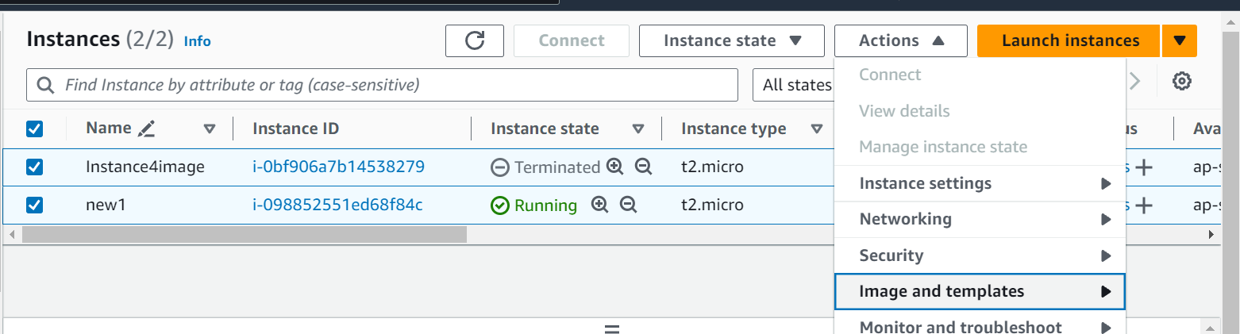

EC2🡪terminate.

AMI🡪Launch instance using AMI.

AMI🡪action🡪deregister AMI🡪snapshot🡪delete.

**Load balancer** :-

Its primary function is **to distribute incoming network traffic across multiple servers**.

--> Key Uses of a Load Balancer

1. **Distributes Traffic:**

- Balances incoming traffic across multiple servers or instances, preventing any single server from being overwhelmed by traffic.

2. **Enhances Reliability and Availability:**

- Improves the availability and reliability of your application by distributing traffic among multiple servers. **If one server fails, the load balancer redirects traffic to healthy servers, minimizing downtime.**

3. **Scales Applications:**

- Supports scaling by automatically distributing traffic to additional servers as demand increases. This helps maintain performance during traffic spikes.

4. **Improves Performance:**

- Reduces latency by balancing the load to the server that is geographically closest to the user or has the quickest response time.

5. **Provides Health Monitoring:**

- Continuously monitors the health of servers and ensures traffic is only directed to healthy instances. This helps in proactive fault tolerance.

--> Types of Load Balancers in AWS

AWS offers several types of load balancers, each suited to different types of applications and workloads:

1. **Application Load Balancer (ALB):**

- **Operates at the application layer (Layer 7) of the OSI model.**

- Ideal for HTTP and HTTPS traffic.

- Supports advanced routing features, such as path-based routing, host-based routing, and support for WebSockets.

- Best for web applications and microservices architectures.

--> **How to Use a Load Balancer in AWS**

Create EC2 (min numbers: 2).

**(User data *- optional*):**

#!/bin/bash

# Use this for your user data (script from top to bottom)

# install httpd (Linux 2 version)

yum update -y

yum install -y httpd

systemctl start httpd

systemctl enable httpd

echo "<h1>Hello World from $(**hostname** -f)</h1>" > /var/www/html/index.html

Launch server🡪change server name.(server1,2….)

1. Set Up the Load Balancer:

- In the AWS Management Console, go to the EC2 Dashboard and select **Load Balancers**.

- Click “**Create Load Balancer**” and choose the type of load balancer you want to create (**ALB**, NLB, or CLB).

2. Configure the Load Balancer:

- **Specify the name**, scheme (**internet-facing** or internal.

- **Mapping**:

Select at least two Availability Zones. **(Ex. ap south-1a,ap south-1b**).

3. Configure Security Groups:

- We are supposed to create rules for inbound rules. Outbound rules will be same.

- Create new security group(open new page)🡪**name**🡪**inbound rules**🡪add🡪http🡪anywhere(0.0.0.0)🡪create🡪Go to load balancer🡪select security group name.

4. **Listeners and routing (target group):**

Create target group (open new page)🡪  target type(instance)🡪 Target group name🡪next🡪 Register targets🡪select server(2 or more)🡪include as pending🡪create🡪select name from loadbalancer🡪create load balance.--> status will be changed(active).-->DNS name copied🡪search google🡪reload the page-reload again & again🡪 Check that traffic is being distributed as expected.

How to delete.

load balancer-->select->action->Delete load balancer->confirm.

Delete security group.

Terminate ec2.

--> **Benefits of Using a Load Balancer:**

- **Scalability**: Automatically adjusts to handle varying levels of traffic without manual intervention.

- **Redundancy**: Provides fault tolerance by distributing traffic among multiple instances.

- **Performance**: Reduces latency and improves application performance by routing traffic efficiently.

- Security: Enhances security with SSL termination and DDoS protection features.

**Putty (Type of software):**

It is used to connect a remote machine using ssh (secure shell is a protocol that allows a secure connection).

Puttygen—>used to generate private key. (.pem to .ppk)

PPK🡪 putty private key.

PUTTY🡪PUB IP->SSH🡪AUTH🡪PPK.

**How connect to ec2 using window cmd.(SSH should be enabled)**

Ec2(linux) launch using .pem key(SSH should be enable)🡪connect🡪**SSH client**🡪copy example given.

(ssh -i "trial_pem_.pem" [ec2-user@ec2-13-201-167-209.ap-south-1.compute.amazonaws.com](mailto:ec2-user@ec2-13-201-167-209.ap-south-1.compute.amazonaws.com))

Open cmd🡪cd Downloads(as pem file location)🡪paste🡪yes.

**How connect to ec2 without SSH enabled:**

It can be done by session manager.

Two services going interact (EC2🡪System Manager).

IAM role will provide permission.

IAM🡪Roles🡪Create Role🡪AWS Services🡪use case=EC2🡪next🡪Add permission🡪search with ssm🡪amazonssmmanagerInstaceCore🡪next🡪name-->create.

EC2🡪AMI🡪network setting 🡪don’t allow SSH🡪Advance Details🡪IAM instace profile🡪select name🡪launch🡪connect🡪session manager.

**Auto Scaling in AWS**

it is a feature that **allows you to automatically adjust the number of EC2 instances in your application according to the current demand**. This ensures that you have the right amount of resources available at any given time, which helps maintain performance and minimize costs. AWS Auto Scaling can be applied to various AWS services, but it's most commonly used with EC2 instances.

Click “**Create Auto Scaling group**.”

Provide a name for the group and **select the launch template** you created.

Configure the network settings(Availability Zones and subnets🡪ap-1a,ap-1b), including the VPC, subnets, and load balancer(no load balancer) if applicable.-->next🡪next.

Set the **desired, minimum, and maximum number of instances**.

Configure scaling policies and health checks.

Review and create the Auto Scaling group.

Step 3: Configure Scaling Policies

Scaling policies define the conditions under which Auto Scaling will adjust the number of instances. You can create dynamic scaling policies, scheduled actions, or predictive scaling policies.

----------------------------------------------------------------------

**Create a Launch Template:**

A launch template defines the configuration of the EC2 instances that will be launched, such as the instance type, AMI, key pair, and security groups.

In the navigation pane, select **“Launch Templates**” and then click “**Create launch template**.”

Provide a name and description for the template.

Specify the instance configuration, including AMI, instance type,key pair(don’t include), security groups(Create group🡪ssh->anywhere), and network settings(don’t includes).

Save the template.

--------------------------------------------------------------------------

#### Configure Scaling Policies

Scaling policies define the conditions under which Auto Scaling will adjust the number of instances. You can create dynamic scaling policies, scheduled actions, or predictive scaling policies.

1. **Dynamic Scaling Policies**:
   * Based on Amazon CloudWatch alarms, which monitor specific metrics such as CPU utilization, network traffic, etc.
   * Create CloudWatch alarms and set thresholds for scaling in or out.
2. **Scheduled Actions**:
   * Specify scaling actions to be performed at specific times, such as scaling out during peak hours and scaling in during off-peak hours.
3. **Predictive Scaling**:
   * Uses machine learning to predict future traffic and automatically scales resources in advance.

**Autoscaling,load balancer,AMI,EC2: NOTE🡪(Don’t use HTTPS.)**

1. Launching an ec2 instance with a user data

2. Create a custom AMI wait for the AMI to be available before terminating the instance

3. Create a Load balancer with a target group and a security group that allows http from anywhere

4. Don't add any targets manually in the target group

5. Create an auto scaling group with a launch template and integrate load balancer

6. while creating launch template select my AMI and owned by me. Also create a new security group that allow http traffic from load balancer sg

9. In ASG specify desired as 2 minimum as 2 maxima as 4 and choose target tracking specify target value as 30

10. create the group test the application by accessing load balancer DNS

11. test the autoscaling action by clicking on load test.

This sequence provides a step-by-step guide to setting up an EC2 instance with Auto Scaling and Load Balancer. Here's a detailed explanation of each step:

--> **Detailed Steps for Setting Up Auto Scaling with Load Balancer**

1**. Launch an EC2 Instance with User Data**:

**User data:**

<https://catalog.us-east-1.prod.workshops.aws/workshops/f3a3e2bd-e1d5-49de-b8e6-dac361842e76/en-US/basic-modules/10-ec2/ec2-linux/2-ec2>

ec2 linux🡪launch a web server🡪copy php user data

- Launch a new EC2🡪copy pub ip🡪check website..

2. **Create a Custom AMI:**

- After configuring the EC2 instance, create an Amazon Machine Image (AMI) from this instance. Wait for the AMI to be available before terminating the instance.

3. **Create a Load Balancer:**

- Set up a Load Balancer **with a target group(DON’T include any server)** and a **security group** that allows HTTP traffic from anywhere.

4. **Do Not Add Targets Manually in the Target Group:**

- Skip the step of adding targets manually to the target group. The Auto Scaling group will handle it.

5. **Create an Auto Scaling Group (ASG):**

- Create an Auto Scaling Group with a launch template that **uses the AMI created in step 2.** 🡪

T2.micro🡪don’t include key🡪don’t include networking🡪security group🡪**Integrate this ASG with the Load Balancer created in step 3.**

6. **Configure the Launch Template:**

- While creating the launch template, select the AMI you created and ensure it is owned by you. Create a new security group **that allows HTTP** **traffic from the Load Balancer's security group**.

Go to load balancer🡪security grp🡪copy security grp id.

Availability Zones and subnets🡪1a,1b🡪load balancer🡪attach existing🡪select🡪next

9**. Specify ASG Parameters**:

- In the ASG configuration, set the desired number of instances to 2, the minimum number to 2, and the maximum number to 4. Choose target tracking scaling policy and specify the target value as 30 (e.g., CPU utilization percentage).-->next->next🡪create.

10. **Test the Application:**

- Create the Auto Scaling group and test the application by accessing it via the **Load Balancer's DNS name.**

11. Test the Auto Scaling Action:

- Simulate load on your application and observe the Auto Scaling action by monitoring how the ASG scales the instances in response to the load.

**Storage option provided by AWS**

### AWS Storage Options

Think of AWS storage like different storage options you have at home:

1. **Block Storage (EBS)**: Like a hard drive you attach to your computer.
2. **File Storage (EFS)**: Like a shared drive everyone in the house can access.
3. **Object Storage (S3)**: Like a big, organized box where you store and label each item separately. (Bucket and objects) (By default private.) (Unlimited data can be stored.) (max. object size = 5TB)

### Block Storage (EBS)

**Example**: Imagine you have a personal hard drive that you plug into your computer. It’s your own space, and you can save anything on it, but only your computer can access it.

* **EBS (Elastic Block Store)**: Just like your hard drive. You attach it to your virtual computer (EC2 instance) in the cloud. It’s fast and can store things like databases or applications that need quick access. If your computer shuts down, your hard drive still keeps the data safe.

### File Storage (EFS & FSx)

**Example**: Think of a shared folder on your home network that everyone in your house can access. You can put files in there, and so can anyone else in the house. It’s great for sharing stuff.

* **EFS (Elastic File System)**: Like a shared folder for all the Linux computers in your house. Everyone can read and write to it at the same time, and it grows automatically as you add more files.
* **FSx (File System for Windows or Lustre)**: Like a shared folder that’s specially set up for either Windows users (FSx for Windows File Server) or for very fast access like for gaming or video editing (FSx for Lustre).

### Object Storage (S3)

**Example**: Imagine a giant box in your attic. Each item in the box has a label so you can find it easily. You can throw in as many items as you want, and it’s super cheap.

* **S3 (Simple Storage Service)**: This is your giant box. You store photos, videos, backups, and more. Each file (object) gets a unique name and a label (metadata) so you can find it easily. You access your files over the internet, just like looking up something in your box.

### Differences in Simple Terms

* **EBS**: Your personal hard drive. Fast, private, and for one computer.
* **EFS**: A shared folder for Linux computers. Easy sharing, automatically grows.
* **S3**: A giant box for everything. Cheap, scalable, and easy to access.

### EBS (Elastic Block Store)

**Think of EBS as a personal USB drive:**

* **Personal and Attached**: You plug it directly into your computer. It's your own space to store things and only you can use it while it's attached.
* **Use Case**: It's fast and good for things like running programs, databases, and applications that need quick access.

**Example**: Imagine you have a USB drive where you keep your important work files. You plug it into your laptop when you need to work, and it gives you fast access to your documents and projects. If you unplug the USB drive and keep it safe, your data is still there even if you turn off your laptop.

### S3 (Simple Storage Service)

**Think of S3 as a giant online photo album:**

* **Shared and Accessible Anywhere**: You can upload photos from anywhere, and access them from any device with internet. You don't need to plug it into a specific computer.
* **Use Case**: It's great for storing lots of data like photos, videos, backups, and other files that you don't need to access super quickly.

**Example**: Imagine you have an online photo album where you store all your vacation photos. You can upload your photos from your phone, your laptop, or any device. You can look at your photos anytime and anywhere as long as you have internet access. The album can hold thousands of photos without any issue.

### Major Differences

**EBS (USB drive):**

* + **Attached to one computer**: Like your USB drive attached to one laptop.
  + **Fast access**: Good for running applications and quick data retrieval.
  + **Specific use**: For your personal, important work files.

**S3 (Online photo album):**

* + **Accessible from anywhere**: Like your online album that you can access from any device with the internet.
  + **Massive storage**: Can store a huge number of files, like thousands of photos.
  + **General use**: For storing a lot of data that doesn't need to be accessed super quickly.

### Summary

* **EBS**: Personal USB drive - fast, personal, and attached to one computer.
* **S3**: Online photo album - accessible from anywhere, massive storage, and great for a large number of files.

**S3:**

Create bucket🡪**Block *all* public access(unchecked)🡪create🡪upload objects🡪add file->upload.**

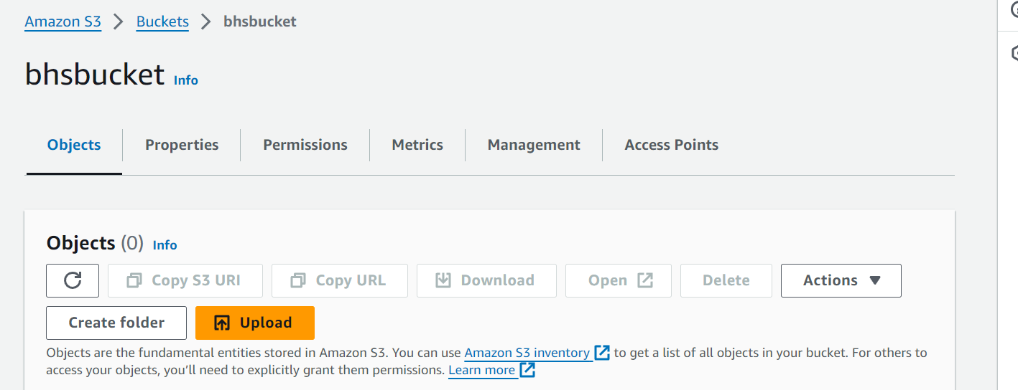

Permission🡪bucket policy->policy generator->s3bucket->allow->*🡪get object->ARN->

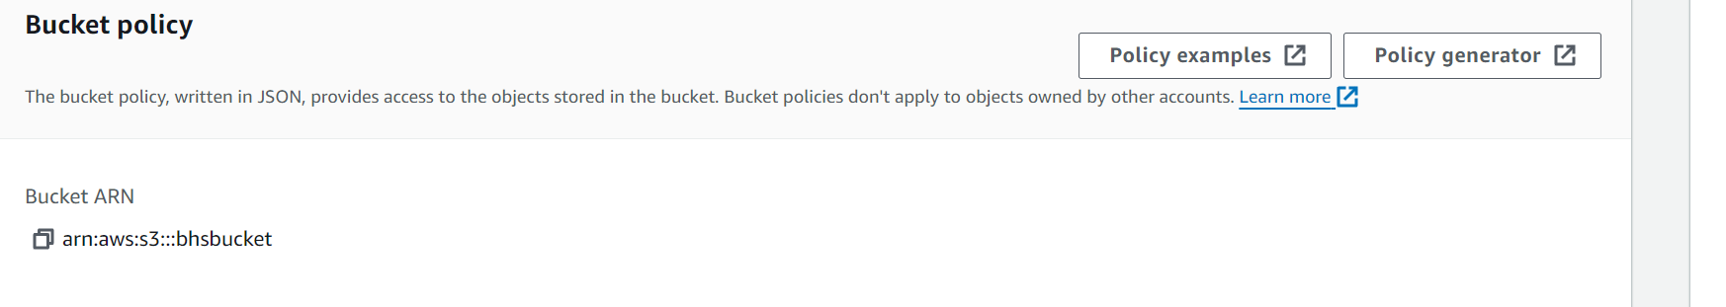



BucketName/* ---🡪 all the objects inside the bucket.

Condition can be added. (ip address)🡪key=vaws sourch ip->value = my ip 🡪add🡪generate policy.

Copy object url(index.html).-->search.

Property:

Static web🡪edit->enable->host static web🡪index.html and error.html should be there as object.

Index.html🡪main webpage.

Error.html🡪if you get error then only.

When you configure your bucket as a static website, the website is available at the AWS Region-specific website endpoint of the bucket.

Now we can download data from s3 to ec2.

Ec2-httpd (run server apachy)🡪download files to http folder from s3 using wget command.

Path : /var/www/html

The **wget** command in Linux is a utility for downloading files from the web. It supports HTTP, HTTPS, and FTP protocols, making it a versatile tool for retrieving content from web servers.

**Connect a 20GB EBS Volume to an EC2 Instance:**

**Step 1: Create an EBS Volume**

**–EC2-->EBS-->VOLUME-->CREATE**

- Size: Enter 20 for 20 GB.

- Availability Zone: Ensure it matches the zone of your EC2 instance (e.g., us-west-2a).

- Volume Type: Choose based on your performance needs (e.g., General Purpose SSD, Provisioned IOPS SSD,Magnetic).

**Step 2: Attach the EBS Volume to Your EC2 Instance**

1. Identify Your Volume:

- In the Volumes list, locate the volume you created.

- Select the volume, click on "Actions", and choose "Attach Volume".

- Instance: Choose the instance you want to attach the volume to.

- Device Name: Accept the default (e.g., /dev/sdf) or specify a different one (e.g., /dev/xvdf).

- Click "Attach".

**Step 3: Connect to Your EC2 Instance**

1. Open a Terminal and Connect EC2.

sudo su.

**Step 4: Format and Mount the EBS Volume**

1. Verify the Volume is Attached:

- List the available disk devices:

lsblk

- You should see the new volume (e.g., /dev/xvdf).

2. Create a Filesystem (USB to file system 🡪mount with newfolder):

- Format the volume:

sudo mkfs -t ext4 /dev/xvdf

3. Create a Mount Point:

- Create a directory where the volume will be mounted:

mkdir newfolder

4. Mount the Volume: (link usb to folder)

- Mount the volume to the directory:

mount /dev/xvdf newfolder

if u want to resize then first change in UI then run command : resize2fs /dev/xvdf

5. Verify the Volume:

Lsblk

**Key Features of S3 Versioning:**

* **Store Multiple Versions:** Each time you modify an object in a versioned bucket, S3 automatically keeps a unique version ID for the updated object.
* **Retrieve Previous Versions:** You can retrieve and restore previous versions of an object if needed.

**Enable Versioning on a Bucket:**

* Open the S3 console.
* Select the bucket you want to enable versioning for.
* Go to the "Properties" tab.
* Click "Versioning" and enable it.

IAM:

IAM (Identity and Access Management) is a global service in AWS. This means that it is not limited to a specific region.

IAM🡪user🡪Username🡪IAMuser🡪Just create a user.

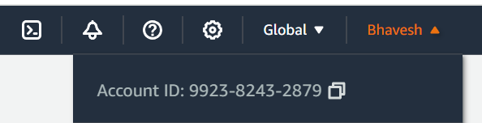

It related to what to allow and what to deny in aws permission.

One to one (1 policy🡪1 user)

One policy ->many user.

User->permission🡪attach policy.

----------------------------------------------------------------------------------------------------------------

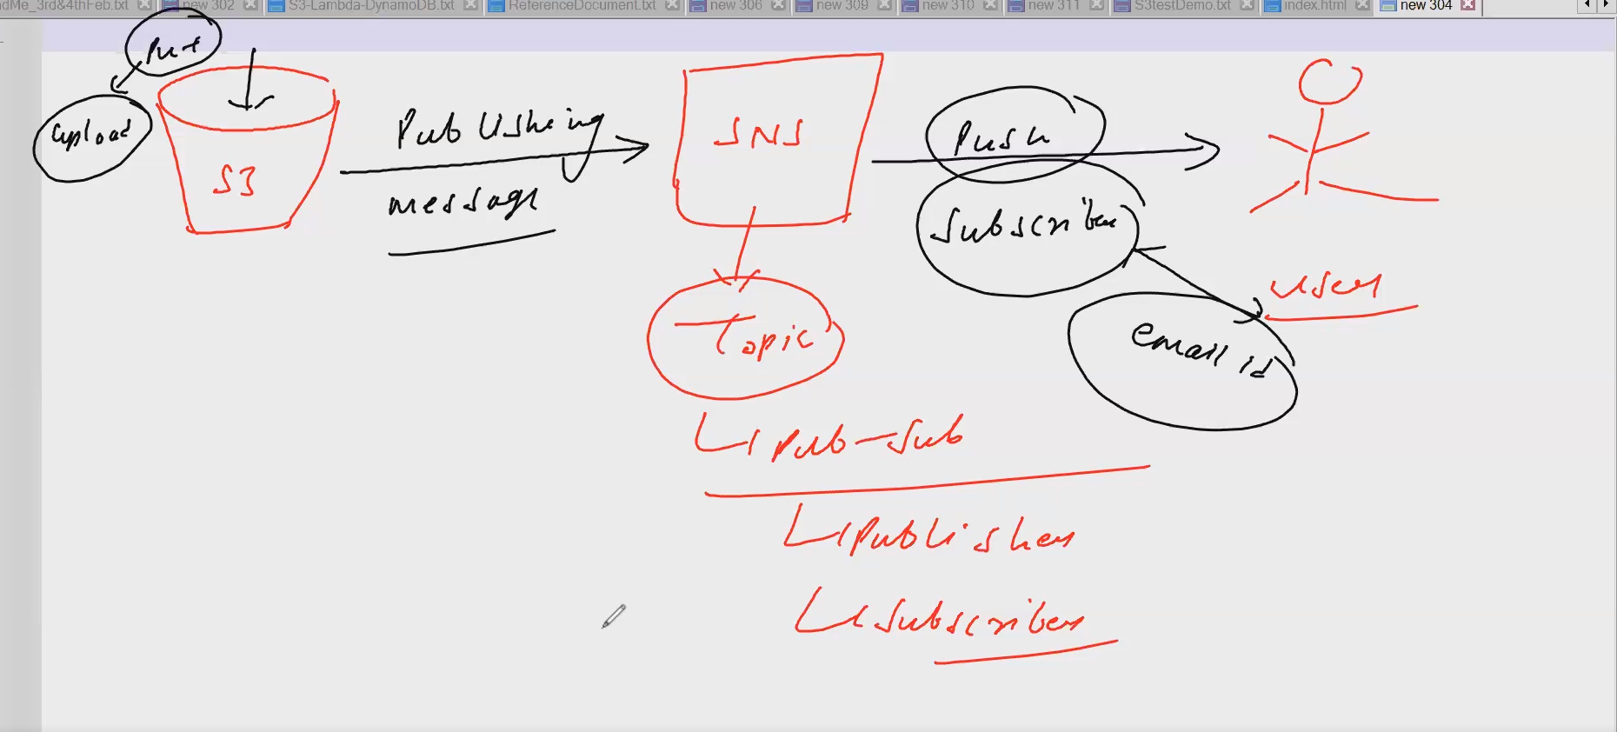

### Key Concepts

* **Publisher**: In this context, the S3 bucket acts as the publisher by sending event notifications to SNS.
* **Subscriber**: The email address acts as the subscriber by receiving notifications from SNS.
* **Pub-Sub Model**: A pattern where publishers send messages to a topic, and subscribers receive those messages from the topic.

### Flow

1. **Upload to S3**: An object is uploaded to an S3 bucket.
2. **Notification Sent to SNS**: The upload event triggers a notification message to be sent to an SNS topic.
3. **SNS Topic Distributes Message**: The SNS topic distributes the message to all its subscribers.
4. **Email Notification**: The subscriber (email ID) receives the notification, and the user checks the email to get the notification.

### Use Case

This setup is useful for scenarios where you need to be notified about changes in your S3 bucket, such as new uploads or deletions. By using SNS, you can easily manage and distribute these notifications to multiple subscribers, ensuring that all relevant parties are informed promptly.

• SNS uses topics to route messages to subscribers.

A topic is a logical access point and communication channel. When you publish a message to a topic, all subscribers to that topic receive the message.

**Multiple Protocols**: SNS supports multiple transport protocols for delivering messages, including:

* HTTP/HTTPS
* Email/Email-JSON
* SMS (Short Message Service)
* SQS (Simple Queue Service)
* Lambda (AWS Lambda function)
* Application (for mobile push notifications)

EVENT NOTIFICATION:

create bucket.()

sns->create topic(standard)->name->create🡪note that ARN.

Subscriptions (Link subscriber(email) to topic.)

select the topic🡪email🡪confirm email.

S3🡪properties🡪event notification🡪create event notification🡪type->put->destination->SNS topic🡪topic ARN🡪error🡪go to access policy in topic🡪save s3 create notification.

{

"Version": "2008-10-17",

"Id": "__default_policy_ID",

"Statement":

[

{

"Sid": "BHS-S3-NOTIFICATION",

"Effect": "Allow",

"Principal": {"Service": "s3.amazonaws.com"},

"Action": ["SNS:Publish"],

"Resource": "arn:aws:sns:ap-south-1:992382432879:newtopic_sns"

}

]

}

**Cross-origin resource sharing (CORS)**

Create 2 bucket :(source and destination)

Bucket-destination🡪 make it as a static web🡪use policy generator to make it as public (*)🡪upload files index.html,error.html,pic.

Bucket-source🡪upload extra page.html🡪use policy generator.

Change index.html 🡪replace the url of extrapage.html🡪upload again to destination bucket it will be overwritten-🡪check with static web url🡪still not visible(extra page content)

Go to source bucket🡪CORS🡪

[

{

"AllowedOrigins": ["http://bucket1bhs.s3-website.ap-south-1.amazonaws.com"],

"AllowedMethods": ["GET"],

"AllowedHeaders": ["Authorization"],

"ExposeHeaders": [],

"MaxAgeSeconds": 3000

}

]

Cross-origin resource sharing (CORS) defines a way for client web applications that are loaded in one domain to interact with resources in a different domain.

IAM 🡪GROUP

An IAM (Identity and Access Management) group in AWS (Amazon Web Services) is a collection of IAM users. IAM groups help manage permissions and policies more efficiently by allowing you to assign permissions to multiple users at once rather than individuals.

**Policy Assignment**:

* You can attach policies to IAM groups just like you would for individual IAM users. Policies define what actions the members of the group can perform on which AWS resources.

**Best Practices**:

* Group users by their job function (e.g., developers, admins, auditors) and assign permissions based on these roles.
* Avoid assigning policies directly to individual users when possible; use groups to manage permissions.

IAM Groups

1. Group is a collection of IAM users

2. A user can belong to multiple groups at a time

3. Groups can't be nested.

**IAM Roles**: (cap)

* Used to delegate permissions to trusted entities, such as IAM users, applications, or services.
* Roles provide temporary security credentials.
* Roles have policies attached to them that define what actions are allowed or denied.

Scenario: Tester is on Leave

**Task**: Tester is usually responsible for running tests on EC2 instances, but is on leave. Developer needs to perform the testing tasks temporarily.

**Roles**: Used to temporarily grant permissions to users or services to perform specific tasks. In this case, TestingRole is created for testing tasks.

EX.

Roles🡪create🡪aws services🡪use case(ec2)🡪permission🡪amazons3read🡪create.

It is valid for 1h which is called session duration.

NAME VIDEO: ROUTES3—18/2/24-JATIN

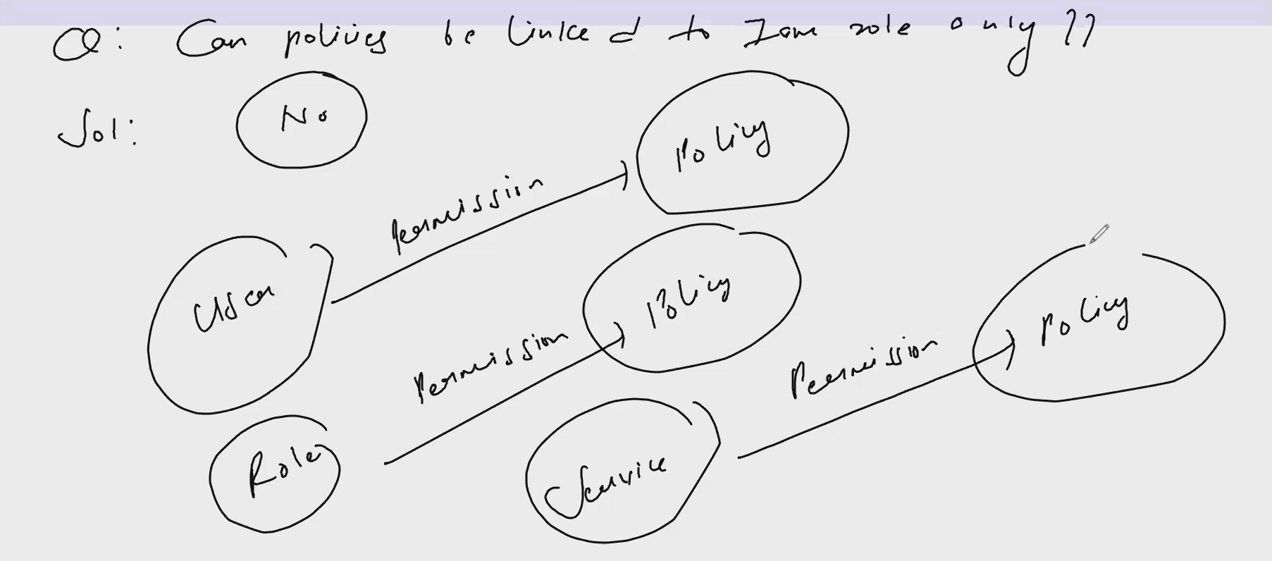

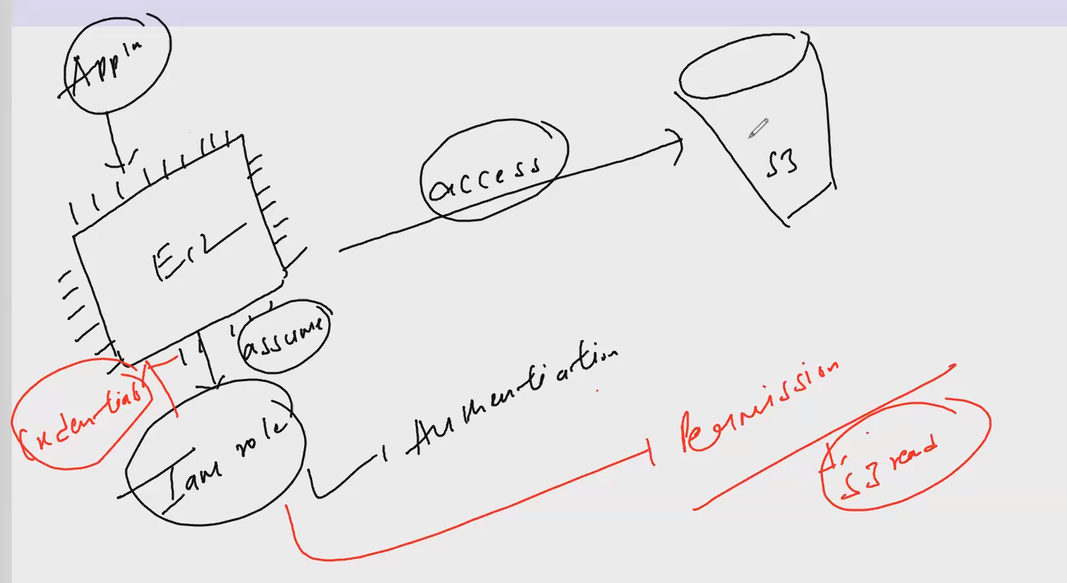

IAM ROLE:

EC2 instances need to interact with S3 buckets.

### 1. IAM Roles and Permissions

**a. Create an IAM Role:**

1. Go to the AWS Management Console.
2. Navigate to the **IAM (Identity and Access Management)** service.
3. Click on **Roles** in the sidebar and then **Create roles**.
4. Select **AWS service** as the trusted entity and choose **EC2** as the use case.
5. Click **Next: Permissions**.

**b. Attach Policies:**

1. Search for and select the **AmazonS3FullAccess** policy if you want to provide full access to S3. For more granular control, you can create a custom policy.
2. Click **Next: Tags** (optional).
3. Click **Next: Review**, give the role a name, and then click **Create role**.

**c. Attach the IAM Role to your EC2 Instance:**

1. Go to the **EC2.**
2. Select your EC2 instance.
3. Click **Actions** > **Security** > **Modify IAM role**.
4. Choose the IAM role you created and click **Update IAM role**.

**Access S3 from EC2**: (List S3 buckets) : aws s3 ls

**Upload to s3**: aws s3 cp localfile.txt s3://your-bucket-name/

**Download from s3**: aws s3 cp s3://your-bucket-name/remotefile.txt ./localfile.txt

AWS General Immersion Day-->Basic Modules-->Security 🡪 AWS IAM-->IAM Hands on Lab

<https://catalog.us-east-1.prod.workshops.aws/workshops/f3a3e2bd-e1d5-49de-b8e6-dac361842e76/en-US/basic-modules/30-iam/iam#identity-and-access-management-(iam)-overview>

IAM🡪create policy🡪create IAM user🡪attach permission which created🡪login with IAM user credential and try to terminate the ec2-prod instance. you won’t be able to terminate as per custom policy.

IAM🡪policy🡪create🡪go to url copy that policy->role🡪attach policy or permission which got created->ec2🡪attach role🡪check.

Amazon CloudWatch is a monitoring service for AWS. It helps you:

* **Track Metrics**: Monitors the performance of your AWS resources (like EC2 instances) and applications.
* **Set Alarms**: Alerts you when something goes wrong or when metrics cross certain thresholds.
* **View Logs**: Collects and helps analyze log data from your resources.
* **Create Dashboards**: Displays metrics and logs in customizable charts and graphs.
* **Respond to Events**: Triggers actions based on specific events or conditions.

To automatically stop an EC2 instance when its CPU utilization goes beyond 50%, you can set up a CloudWatch alarm.

**A Virtual Private Cloud (VPC): logically isolated virtual network.**

**CIDR:** A CIDR block (Classless Inter-Domain Routing block) is a method for defining IP address ranges.

#### 1. The Big Picture: CIDR Block Format

* **CIDR Notation**: 10.0.0.0/16
  + **10.0.0.0**: The starting IP address of the block.
  + **/16**: The number of bits used for the network portion of the address. Called subnet mask. Range between /16 to /28.--> 65536 IP to 16 IP.

#### 2. The Ocean of IP Addresses

* **CIDR Block**: 10.0.0.0/16
  + **Range**: 10.0.0.0 to 10.0.255.255
  + **Network Portion**: The first 16 bits (10.0) are used to identify the network.
  + **Host Portion**: The remaining 16 bits are used for individual devices.

#### 3. Diving Deeper: Subnetting (subnet is subset of VPC)

* **VPC Block**: 10.0.0.0/16
  + **Subnet A**: 10.0.1.0/24
    - **Range**: 10.0.1.0 to 10.0.1.255
  + **Subnet B**: 10.0.2.0/24
    - **Range**: 10.0.2.0 to 10.0.2.255

Each /24 subnet contains 256 IP addresses (including network and broadcast addresses).

#### 4. Flexible Allocation: Beyond Classes

* **Traditional Classes**: IP addresses were once divided into fixed classes (A, B, C).
* **CIDR**: Allows flexible allocation. Instead of being restricted to specific sizes, CIDR lets you define custom-sized blocks.

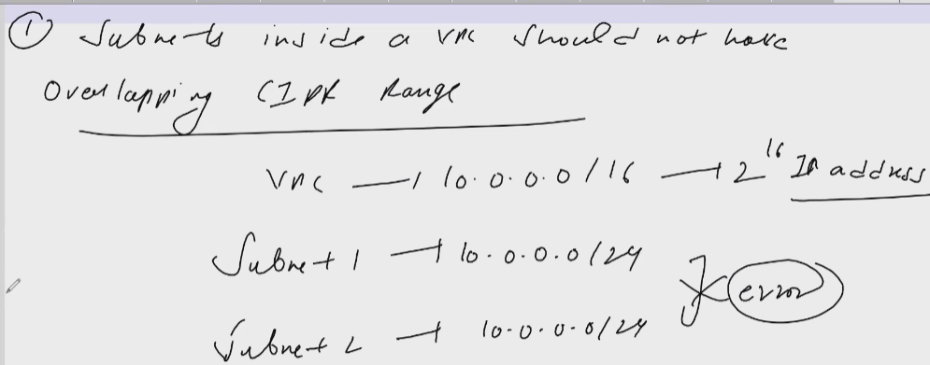

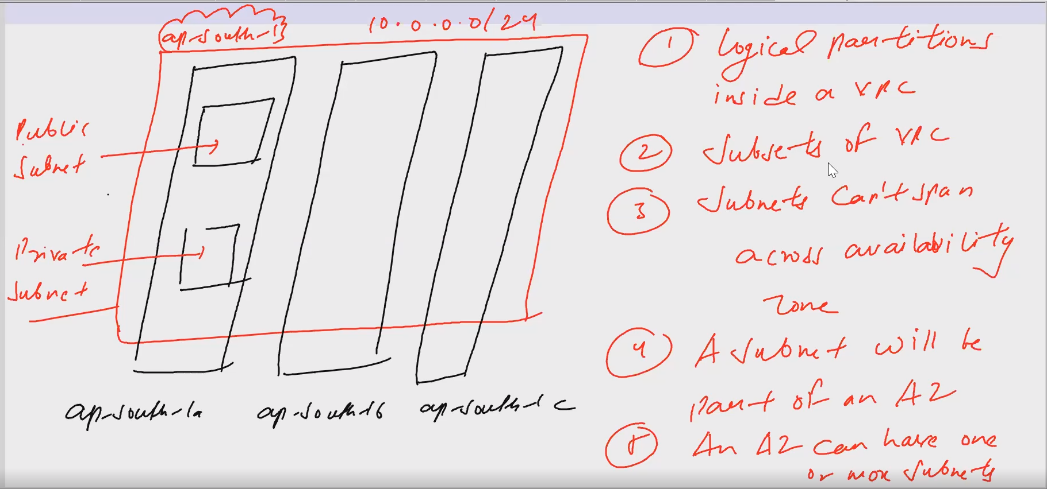

**Route Tables**: Determines where network traffic is directed. You can create custom route tables to control traffic flow between subnets and to/from the internet or VPN.

VPC—Default route table🡪main route table. -->default entry in route table🡪traffic can flow in VPC locally.

Subnet🡪Each subnet in VPC will have route table associated with it.

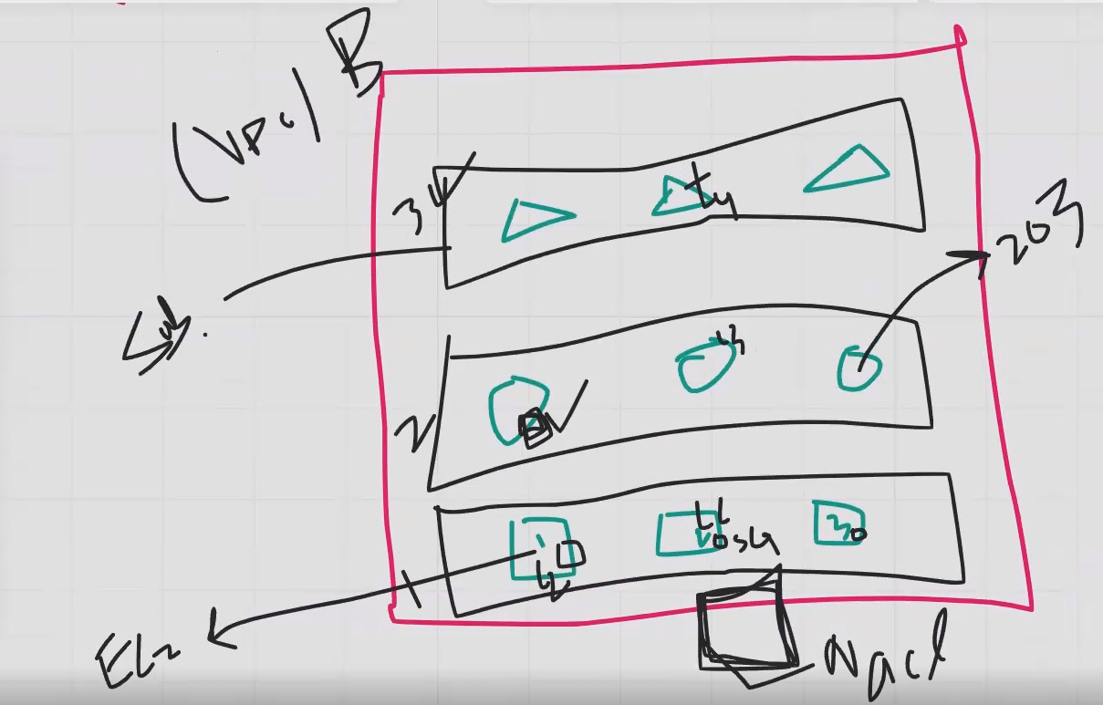

**ICMP (Internet Control Message Protocol)** is a network protocol.

**Checking Connectivity**: You can use tools like ping to see if your EC2 instance is reachable. It sends ICMP Echo Request messages to the instance, which responds with Echo Reply messages if it's up and running.

VPC:

By default both subnets are private.

VPC (10.0.0.0/16)🡪create with vpc only 🡪subnet🡪create 2 subnet (10.0.0.0/24 and 10.0.1.0/24)🡪EC2🡪network setting🡪select VPC & SUBNET_1🡪auto assign public ip🡪enable🡪launch🡪connect🡪error will be there as default subnet is private(ec2 should be accessible from internet ).

**Internet Gateway (IGW)**: A gateway that allows communication between your VPC and the internet. It’s used for public subnets to access the internet.

IGW🡪just create🡪action🡪attach to vpc.

**Route Tables**: Determines where network traffic is directed. You can create custom route tables to control traffic flow between subnets and to/from the internet.

Create custom route table🡪name🡪select VPC🡪Create. 🡪edit routes🡪add route🡪destination = internet (0.0.0.0/0) and target=IGW

Subnet 🡪 SUBNET_1🡪select 🡪action and edit route table association🡪select route table.

Now check ec2 and connect.

---------------------------------------------------------------------------------------------------------------

1. Create a VPC with two subnets if not already present.

2. Create an internet gateway and attach it to VPC.

3. Create a route table for your VPC and add an entry to internet gateway.

4. Associate the route table to one of the subnets. This subnet will be known as public subnet.

5. Launch an EC2 instance in your custom VPC and public subnet.

6. Enable auto assign public IP.

7. Test the connectivity using EC2 instance connect.

Create VPC with VPC and more option.

2 EC2🡪1 in pub subnet and 2nd in private subnet. (not required SSH)--test(ping) the ec2(private subnet) from ec2(public subnet)

Goto pub ec2 and connect 🡪 ping <private ec2 ip>

It won’t work. Goto private ec2 security grp🡪inbound🡪ICMP from anywhere or u can select custom icmp from pub ec2 subnet CIDR

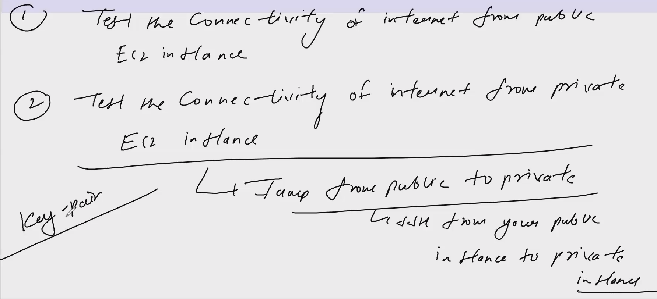

EC2🡪with key pair(pem)📫📫VPC—private subnet🡪ssh from public subnet CIDR🡪launch.

Connect with public ec2🡪ping.www.google.com🡪jump from public ec2 to private ec2🡪copy the value of key and make file in ec2 with same key name🡪vi mykey.pem🡪press i🡪copy paste🡪esc🡪:wq🡪chan ge permission🡪chmod 400 <name>🡪connect with step 4

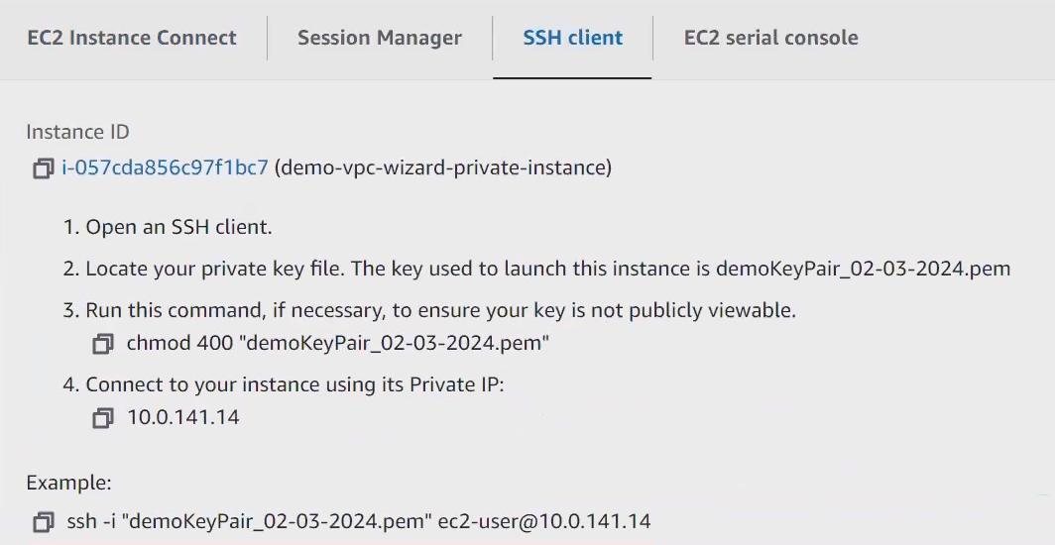

**NAT Gateway (it is not free)**: Allows instances in a private subnet to access the internet without exposing them directly. Only outbound traffic not inbound traffic.

Create NAT🡪select public subnet🡪allocate elastic ip🡪create.

Update the route table of private subnet🡪destination=internet (0.0.0.0/0) and target=NAT Gateway.

Now run ping command from private ec2🡪ping [www.google.com](http://www.google.com)

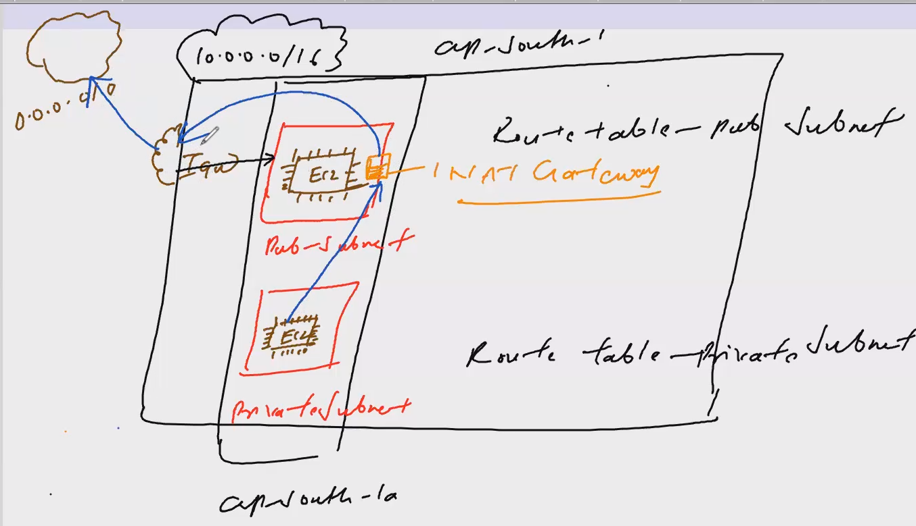

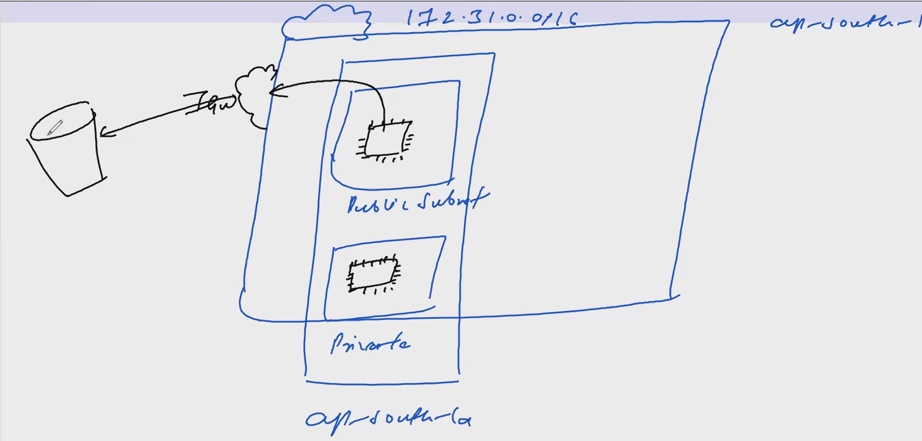

VPC endpoint:

Create VPC:

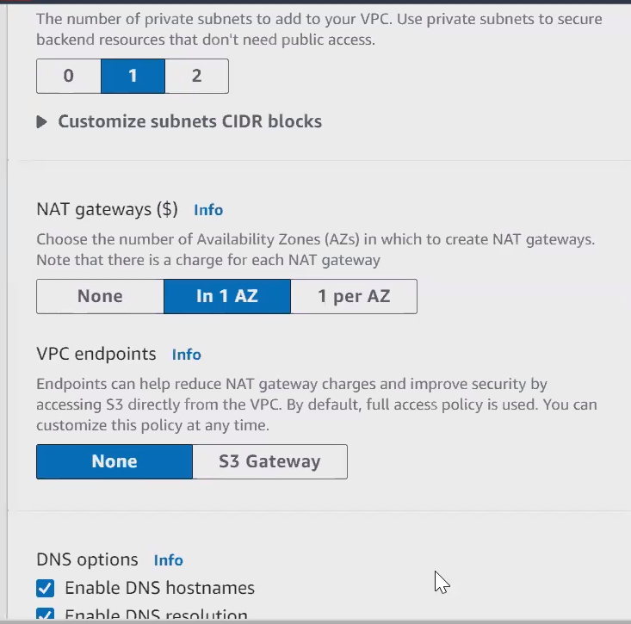

A **VPC Endpoint** is a way to privately connect your AWS VPC to AWS services without using the internet. It keeps your data within the AWS network, providing a secure and efficient way to access services like S3 and DynamoDB.

Create pub ec2🡪create private ec2 using keypair SSH from CIDR pub subnet🡪IAM—creare role—ec2—s3 read—create🡪goto ec2 and attach role to both ec2(action—security—modify IAM role)-->connect pub ec2🡪aws s3 ls🡪connect to private ec2 using pem fiile.-->check the same. It can be done by NET gateway.-->delete NET gateway and check.

VPC ENDPOINT:

Create endpoint🡪aws services—select s3—type as gateway—select VPC—route table select private one🡪create🡪goto route table of endpoint🡪check route—entry for endpoint will be updated.-🡪now check with aws s3 ls – region ap-south-1

**VPC Peering** is a way to connect two VPCs in AWS so that they can communicate with each other as if they were on the same network. This allows resources in one VPC to interact with resources in another VPC securely and privately, without using the public internet.

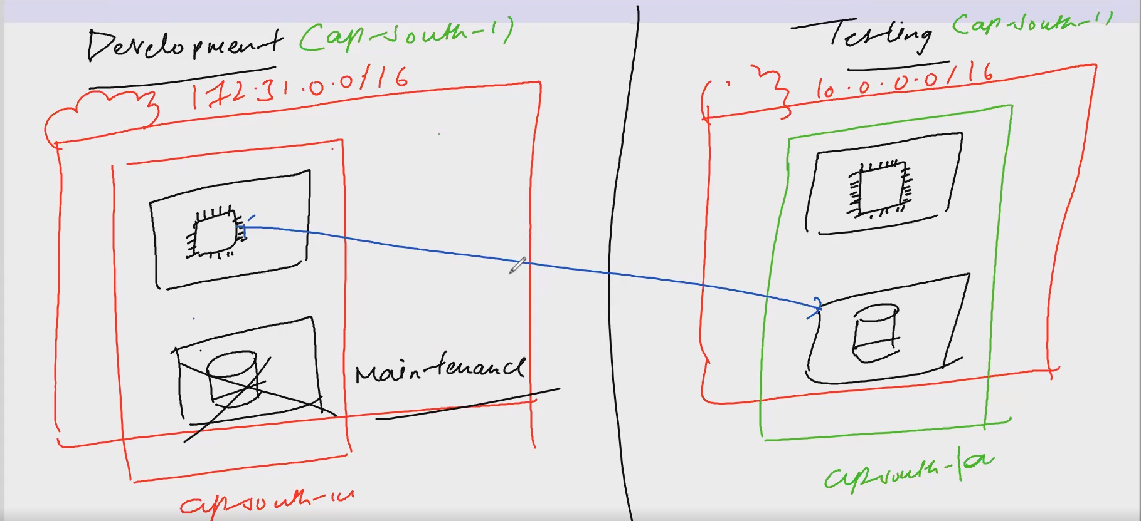

**ICMP (Internet Control Message Protocol)** is a network protocol.

**Checking Connectivity**: You can use tools like ping to see if your EC2 instance is reachable. It sends ICMP Echo Request messages to the instance, which responds with Echo Reply messages if it's up and running.

What is VPC Peering?

A VPC peering connection is a networking connection between two VPCs that enables you to route traffic between them privately.

Features of VPC Peering

1. There is one to one relationship between two VPC's

2. VPC peering is not transitive in nature

3. VPC peering can be created for VPCs in the same region, in different region, in same account

in different account

4. VPCs involved in peering should not have overlapping CIDR

5. Route tables of VPCs need to be updated

**VPC Peering Exercise**

1. Create two different VPC with non-overlapping CIDR

E.g. **VPC 1- requester** - 172.31.0.0/16, **VPC 2- acceptor** - 10.0.0.0/16

2. Launch an EC2 instance in each of the above VPC in public subnets with ICMP from everywhere in the security group rule

3. Test the ping connection in these Ec2 instances 🡪result: timeout

4. Create a peering connection

5. Accept the peering connection

6. **Update the route tables of public subnets** in each of these VPC

7. Test the connectivity🡪result: ping successful

ROUTE 53:

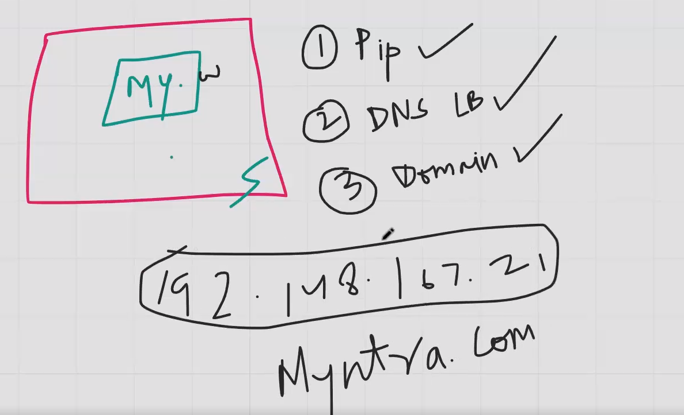

EC2 ---- Virtual servers

EC2--> AMI --> Launch Template --> Auto scaling group.

* To get the result of your server --> Public IP

* To get the result of your server --> DNS of Load balancer.

* To get the result of your server --> Domain names.

Route53.

---------

Single Instance:

1: Hosted Zones --> NAME SERVERS, SOA

2: Registered domains --> Edit my name servers with the name servers in hosted zones

3: Public ip --> mention it in the "value box" and save.

Multiple Insatnces:

1: Hosted Zones --> NAME SERVERS, SOA

2: Registered domains --> Edit my name servers with the name servers in hosted zones

3: Alias --> DNS of load balancer along with Region and Name of load balancer

4: Click on Create Record.

COMMANDS FOR EC2 UBUNTU.

1: Update : sudo apt-get update -y

2: Apache2 : sudo apt-get install apache2 -y

3: Directory : cd /var/www/html

4: Listing : ls

5: Removing of file : sudo rm index.html

6: Creating new index file : sudo nano index.html

7: ctrl +s and ctrl +x

DATABASE 🡪RDS:

Amazon RDS (Relational Database Service) that makes it easy to set up, operate, and scale a relational database in the cloud.

it allows you to use database software like MySQL, PostgreSQL, Oracle, SQL Server without worrying about the underlying hardware or infrastructure.

**Managed Service**: **AWS handles** the administrative tasks such as **hardware** provisioning, database setup, patching, and backups.

**Automatic Backups**: RDS automatically takes backups of your database.

**High Availability**: With Multi-AZ deployments, RDS automatically replicates data to a standby instance in a different Availability Zone.

**Cost-Effective**: You only pay for what you use.

RDS—create—**username**—**password**—instance type--public access—default VPC, AZ—create—if popup –hide and close—status will be available.

**MySQL workbench software**—host name=endpoint (RDS—Connectivity--endpoint)—3306 as port—username& pass—test connection-connect.

Launch **EC2** without key, amazon linux 2 AMI, default—connect—sudo su—mysql --version—yum install -y mysql—mysql -h <host-name> -P 3306 -u <user-name> -p –enter password

(host-name=endpoint,P=port,p=password)

Mysql>show databases.

Goto security grp of RDS—inbound—2 entry should be there—all traffic from anywhere and same security grp id.

SECURITY GROUP-Sg1-Sg2-chaining.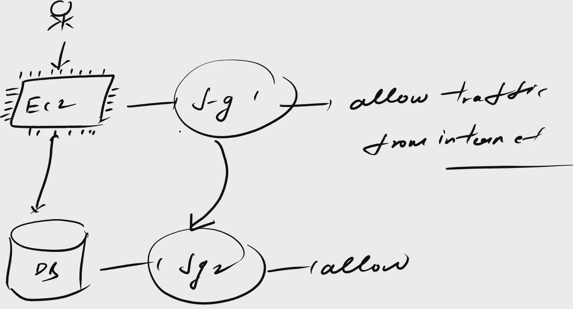

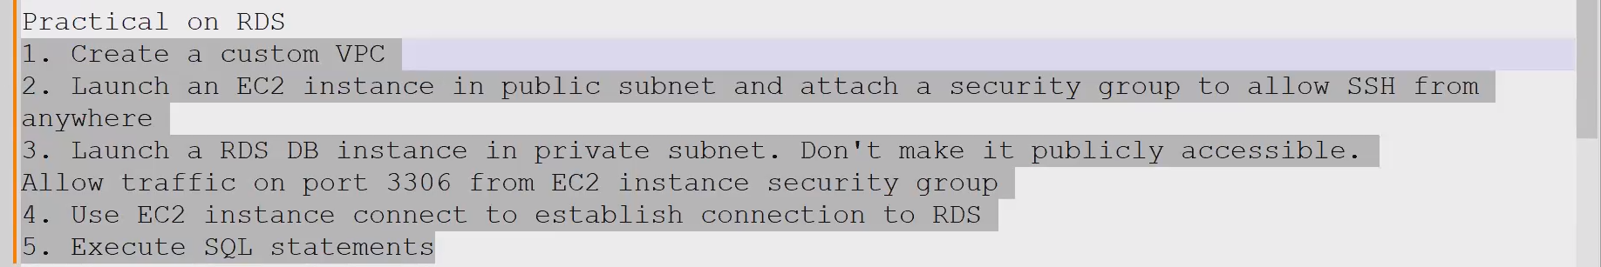

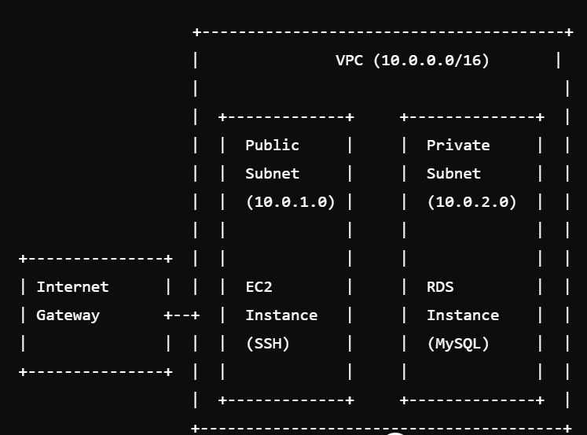

Create VPC with 2 or more AZ.

EC2—VPC(publilc subnet)—ssh from anywhere—launch.

Create **security grp** for db—select custom vpc—mysql(port 3306) from security grp of ec2.

RDS—create—user name—password—select custom vpc—db subnet—**createnewsubnetgrp and select**—public access=no—**select custom security grp.**

**--------------------------------------------------NOTE-----------------------------------------------**

**Subnet group = combination of AZ + subnet**

**EC2 –connect—mysql –version---yum install -y mysql.**

**EC2—PHP web—role—secret manager permission—create role—attach role to ec2—create db—go to secret manage—set user name & password & end point with name mysecret—this name will be used in web page. –click RDB—record will be generated.**

EFS:

**Scalable**, **shared file storage for EC2 instances**.

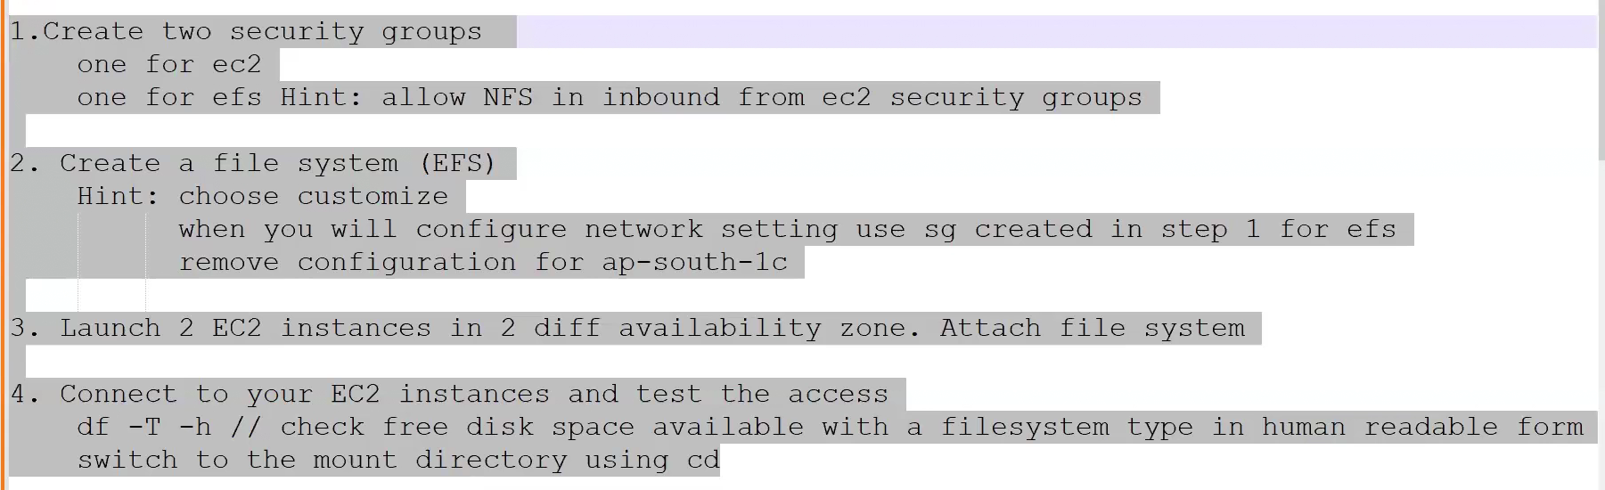

**Use Cases**

* **Web Hosting**: Highly available web content.
* **Content Management**: Large volumes of shared data.
* **Big Data**: Shared access for analytics.

**Important Notes**

* **Security**: Ensure NFS traffic is allowed in security groups.
* **Monitoring**: Use CloudWatch for performance insights.
* **Backup**: Use AWS Backup for automated backups.

**AWS Lambda Key Points: (serverless application development)**

1. Serverless Computing:
   * **No need to manage servers; AWS handles the infrastructure.**
2. Event-Driven:
   * **Executes code in response to events** (e.g., S3 uploads, DynamoDB updates, API Gateway requests).
3. Automatic Scaling:
   * Scales automatically based on the number of requests.
4. Cost-Effective:
   * Pay only for what you use.
5. Supported Languages:
   * Node.js, Python, Java, Go, .NET Core, Ruby.
6. Integration:
   * Works seamlessly with other AWS services like S3, DynamoDB, Kinesis, and API Gateway.

Basic Workflow

1. **Create Function:**
   * Write or upload your code in the AWS Lambda console.
2. **Set Up Triggers:**
   * Configure events that will invoke your function (e.g., S3 event).
3. **Execute and Monitor:**
   * AWS Lambda runs your code in response to events. Use CloudWatch for monitoring and logging.

Example Use Cases

1. Real-Time Data Processing:
   * Process streaming data from Kinesis or DynamoDB.
2. Web and Mobile Backends:
   * Handle backend logic for web and mobile apps.
3. Automation:
   * Automate tasks like data backups and resource management.
4. Microservices:
   * Build microservices with functions that handle specific tasks.

------------------------------------------------------------------------------------------------------------

**Create lambda**—use blueprint—**get s3 obj**(python 3)—function name—use an existing role—go to IAM—create role—use case=lambda—add permission—s3read & cloudwatch log—create role—lambda—**use an existing role**—**code**—create just s3 bucket—add trigger in lambda—select s3 & bucket—event as put—add—upload file to s3—lambda dashboard—monitor—view cloudwatch log,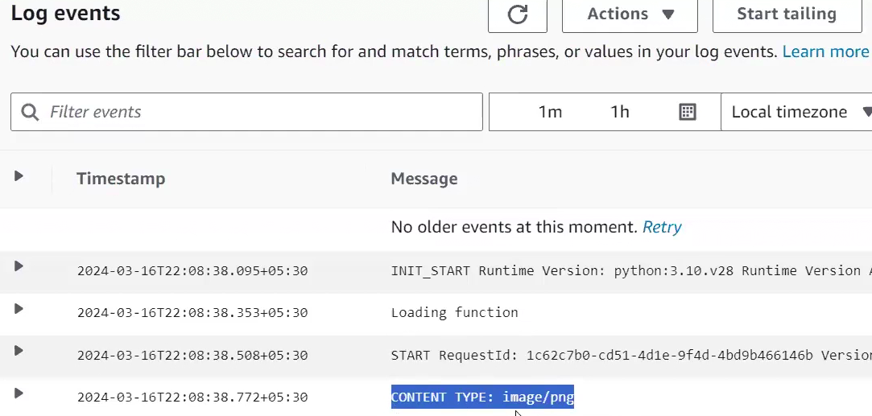

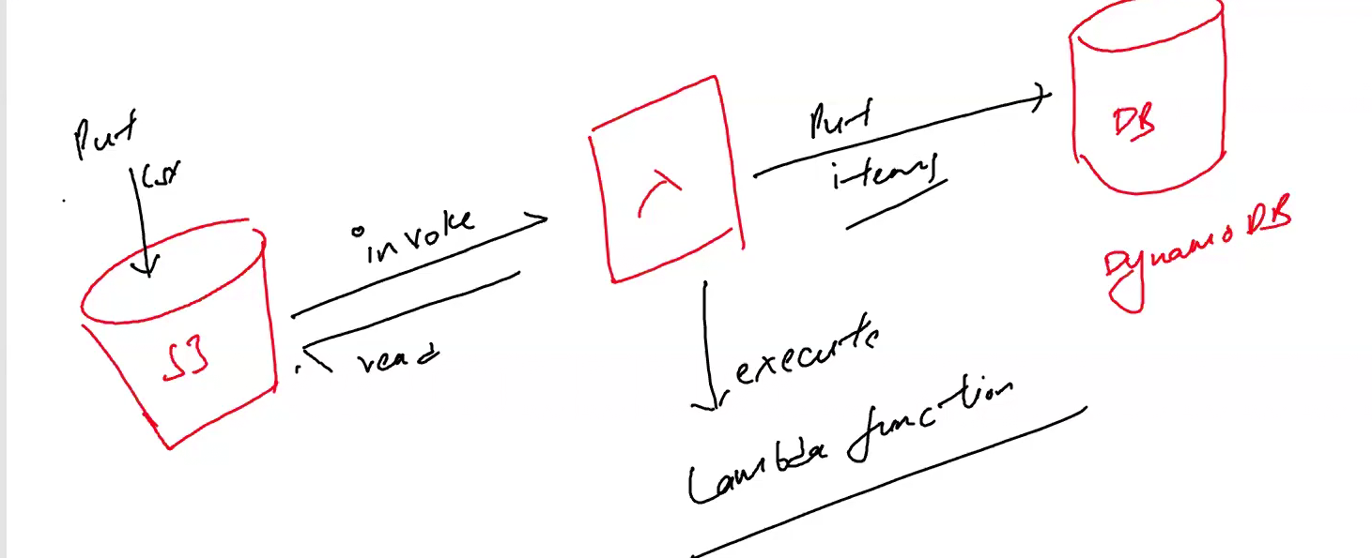

**Summary**

1. Create DynamoDB table.
2. Create S3 bucket.
3. Create Lambda function.
4. Write Lambda function code to process S3 events and write to DynamoDB.
5. Add S3 trigger to the Lambda function.
6. Ensure proper IAM roles and permissions.
7. Test the setup by uploading a file to S3 and checking DynamoDB.

**Route 53**

Amazon Route 53 is a Domain Name System (DNS) web service.

It is designed to route end users to Internet applications by translating human-readable names like [www.example.com](http://www.example.com) into the numeric IP addresses like 192.0.2.1 that computers use to connect to each other.

Route 53 is named after the TCP/UDP port 53, where DNS server requests are addressed.

**DNS Records**:

* **A Record**: Maps a domain to an IPv4 address.
* **AAAA Record**: Maps a domain to an IPv6 address.
* **CNAME Record**: Maps a domain to another domain name.

**Routing Policies**:

* **Simple Routing**: Basic routing without any special routing logic.
* **Latency-based Routing**: Route traffic to the resource with the lowest latency for the user.
* **Failover Routing**: Route traffic to a secondary resource if the primary one fails.
* **Geolocation Routing**: Route traffic based on the geographic location of the user.

**AWS CloudFormation** is a service that allows you to define and manage your AWS **infrastructure as code**.

**Create templates** 🡪describe the resources and configurations you want.

**Template**: A JSON or YAML file that describes the AWS resources you want to create and configure. It includes:

**Amazon Elastic Beanstalk (EB**) is a Platform as a Service (PaaS)

offered by AWS that makes it easy to deploy, manage, and scale applications and services.

Ideal for quickly deploying and managing web applications with minimal infrastructure management.

**Less control over infrastructure**; more suitable for standard web applications.

**SQS**:

**Amazon SQS (Simple Queue Service)**

* **Message Queueing Service**: SQS is designed for decoupling (There is no 1:1 mapping) and scaling distributed systems and microservices.
* **Pull-Based Delivery**: Messages are stored in queues, and consumers pull messages from the queue.

### When to Use Each Service

* **Use SNS**: When you need to send notifications to multiple endpoints or services, such as sending alerts to both email and SMS subscribers.
* **Use SQS**: When you need to decouple components of a system, handle background processing tasks, or ensure reliable message processing with retries and dead-letter queues.

|  |  |  |
| --- | --- | --- |
| **Feature** | **Amazon SNS** | **Amazon SQS** |
| **Messaging Pattern** | Pub/Sub (Publish/Subscribe) | Point-to-Point (Queue) |
| **Delivery Method** | Push | Pull |
| **Use Case** | Real-time notifications, broadcasting | Decoupling microservices, task queues |
| **Message Delivery** | Multiple subscribers, fan-out | Single consumer per message, scalable consumers |
| **Message Ordering** | Not guaranteed | FIFO queues provide ordering |
| **Retries** | Managed by SNS | Managed by consumers |
| **Dead-Letter Queue** | No built-in support | Supported |

**How do I use Lambda to stop and start Amazon EC2 instances at regular intervals?**

<https://repost.aws/knowledge-center/start-stop-lambda-eventbridge>

<https://catalog.workshops.aws/general-immersionday/en-US/basic-modules/40-monitoring/monitoring>

In this lab, you will utilize CloudWatch to track EC2 CPU utilization and set up Alarm based on a configured threshold. The Alarm will trigger a Simple Notification Service(SNS) notification.

1. Create Simple Notification Service (SNS) Topic
2. Launch an Elastic Compute Cloud (EC2) Instance
3. Configure a CloudWatch Alarm

VPC assignments:

1. Create a VPC with 120.0.0.0/16 CIDR block.

2. Create 1 public subnet 2 private subnets and make sure you connect a NAT gateway for internet connectivity to a private subnet.

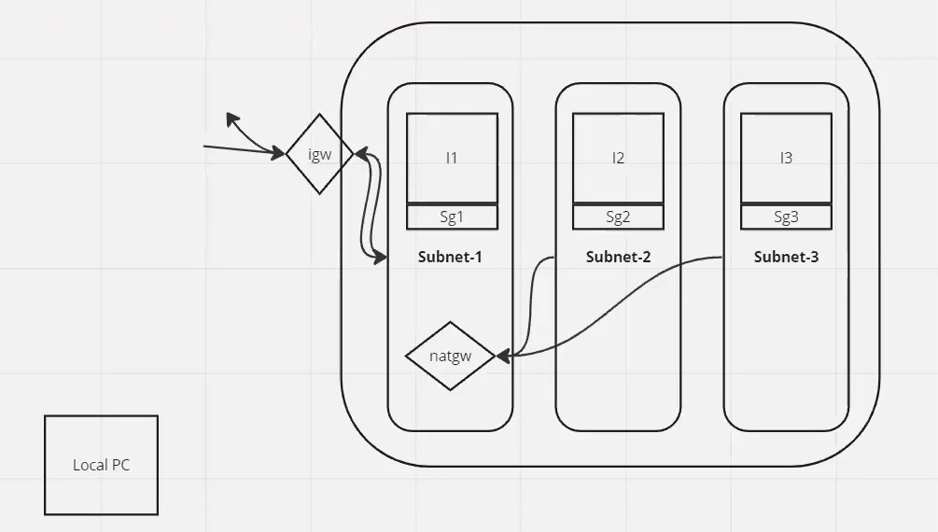

NOTES:

IGW—2WAY— attached to VPC—PUB SUB ROUTE TABLE(0.0.0.0/0 using IGW)

NAT—1WAY—attached to public sub—create.

Route table— (anywhere using NAT)—set association with private subnet.

Problem Statement:

1. Create a VPC endpoint for a S3 bucket of your choice for secure access to the files.

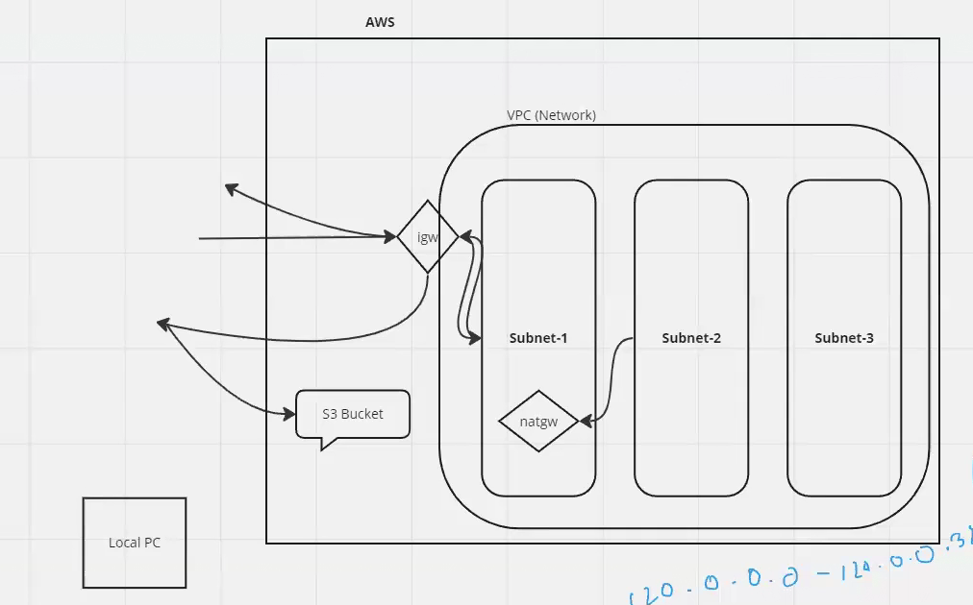

If I try to access the S3 bucket from subnet1(pub) or subnet2(private) then it won’t be secure due to internet access.

I will use vpn endpoint.

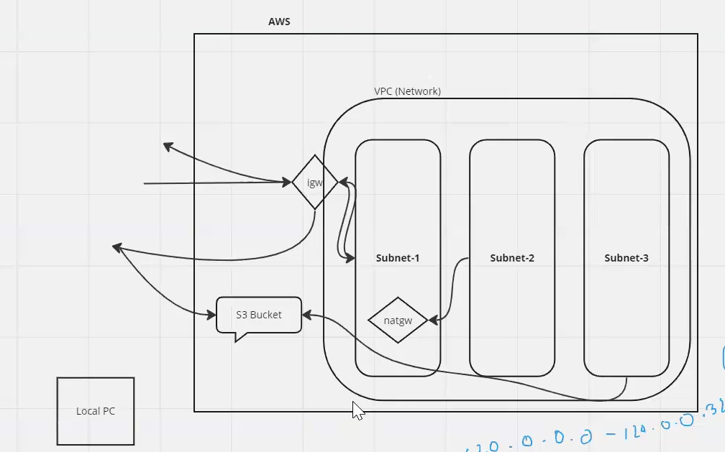

IAM role given to EC2-Subnet3—route table—select vpc—subnet.

VPC endpoint—select S3--Gateway—VPC—route table.

Gateway type:

Interface 🡪for 1 instance

Gateway🡪for entire subnet

ASSIGNMENT 3:

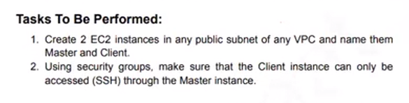

**you can access a private subnet from another private subnet within the same VPC.**

**By default, all subnets within a VPC can communicate with each other.**

This is because the VPC automatically creates route tables that allow internal communication between all subnets.

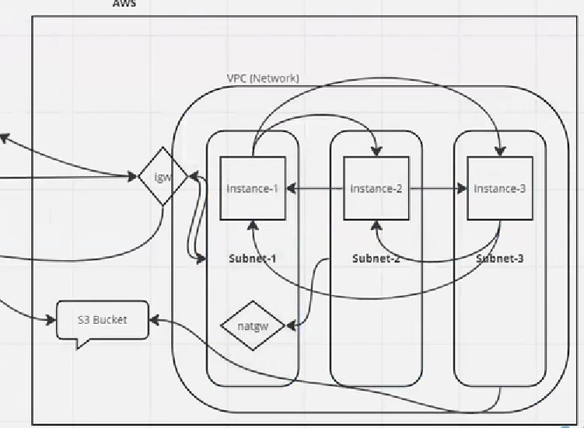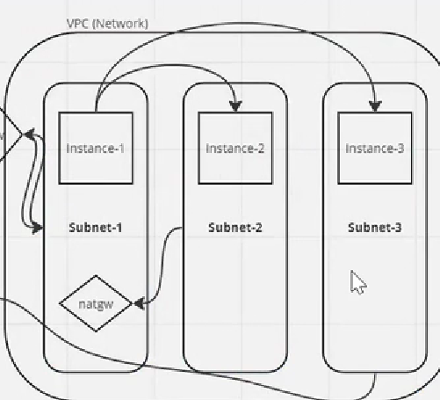

Only ec2_1 subnet1 should access remaining two server within same vpc.

Security grp of 2 & 3-🡪sourch = private ipv4 of ec2_1

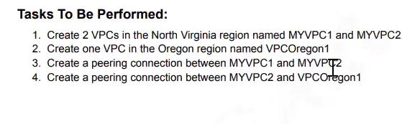

**Select region virginia.**

VPC_1—PUB SUB—**EC2_1**-- ALL ICMP—ping to pubip of **EC2_2—will work. Now ping to Private ip of EC2_2—won’t work.**

VPC—>Peering connection—select region (Oregon)—select VPC2—Create and send req.— route table – CIDR of VPC2 USING peering connection

**Select region Oregon:**

VPC_2—PUB SUB—**EC2_2**—ALL ICMP.

VPC—>Peering connection—> Accept request—subnet--route table---CIDR OF VPC1 USING peering connection.

VPC peering connection is a networking connection between two VPCs that allows traffic to be routed between them using private IP addresses

Yes, you can think of VPC peering between different regions as making the two VPCs act like one network, allowing them to communicate as if they were in the same VPC.

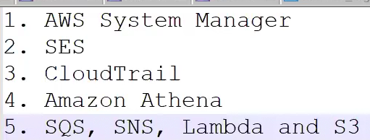

1. **Set up S3 buckets**: Source and result.
2. **Use AWS Glue Crawler**: To catalog source data.
3. **Create an AWS Glue ETL Job**: To transform data and store it in the result bucket.
4. **Query with AWS Athena**: To analyze the transformed data.

This setup enables a seamless ETL process, from raw data in S3 to querying the transformed data using Athena.

**. Cataloging with AWS Glue Crawler**

1. **Run the Crawler**:
   * The Crawler scans the data in the source bucket, determines the format (e.g., CSV, JSON), and creates metadata tables in the Glue Data Catalog.
   * After the crawler runs, the Glue Data Catalog holds metadata about the data in your source bucket, which includes table definitions, column names, data types, and location in S3.

**Amazon Athena** is a serverless query service that allows you to analyze data directly in Amazon S3 using standard SQL.

It is designed to make it easy to query large datasets without the need to manage infrastructure or setup a data warehouse.

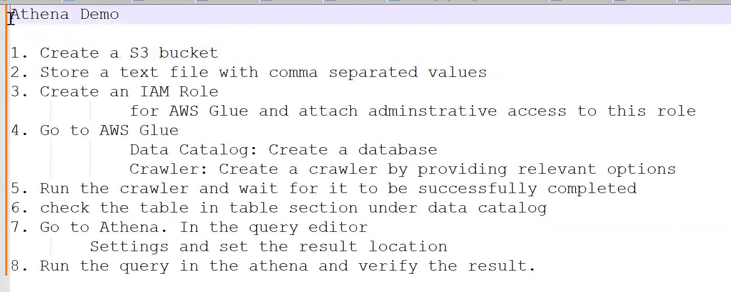

Amazon Redshift

It is a cloud-based data warehouse service provided by AWS, designed for large-scale data storage and analysis. It's powerful, cost-effective, and integrates well with other AWS services.

Amazon Redshift is a **fully managed** data warehouse service that makes it easy to run complex queries and analyze large datasets quickly. It is optimized for high performance and scalability, making it suitable for **data warehousing and big data analytics.**

AWS Faqs : https://aws.amazon.com/faqs/

**AWS Workshop**: https://workshops.aws/

ELB Integration with Route 53 :https://docs.aws.amazon.com/Route53/latest/DeveloperGuide/routing-to-elb-load-balancer.html

AWS Educate

https://aws.amazon.com/education/awseducate/

AWS Ramp Up Guide

https://aws.amazon.com/training/ramp-up-guides/

AWS Cloud Quest Skill Builder

https://aws.amazon.com/training/digital/aws-cloud-quest/

Notes:

Amazon Redshift

Amazon Redshift is a fully managed data warehousing service provided by AWS. It allows businesses to analyze large amounts of data across their data warehouses using standard SQL queries.

Amazon ElastiCache

Amazon ElastiCache is an AWS managed cache service that makes it easy to set up, manage, and scale popular open-source in-memory caches

like Redis and Memcached in the cloud.

API Gateway

It is a front door for all the APIs request. It is a gateway that allows you to create, publish,

maintain, monitor and secure APIs at scale.

Amazon Kinesis

It is a platform or service to process real time streaming data at massive scale.

1. Amazon Kinesis Data Stream

2. Amazon Kinesis Delivery Stream (Amazon Kinesis Data Firehose)

3. Amazon Kinesis Video Stream

4. Amazon Kinesis Data Analytics

**Amazon CloudFront**

It is a content delivery network service which is used to distribute the static and dynamic

content globally.

**AWS Global Accelerator**

It is a service that improves the availabilty of application and enhance the performance over the

internet.

**Network Adapters**

ENA vs EFA vs ENI

A Network Adapter is a device which is allowing a machine to connect to a network or communicate to

other devices

Elastic Network Adapter, Elastic network interface, Elastic Fabric Adapter

are network interfaces.

ENA, EFA, and ENI are all networking features provided by Amazon EC2. ENA stands for Elastic Network Adapter, which is a network interface that can be attached to EC2 instances. It provides improved network performance and lower latency compared to traditional network interfaces.

EFA stands for Elastic Fabric Adapter. EFA builds upon ENA by adding additional capabilities for high performance computing (HPC) and machine learning workloads. EFA supports features like OS bypass that allow applications to communicate directly with the network interface for lower overhead. It works with libraries and frameworks like Open MPI, Intel MPI, and Nvidia NCCL.

ENI stands for Elastic Network Interface. An ENI represents a virtual network interface in your VPC. It contains attributes like private IP addresses, security groups, MAC address etc. ENIs can be created separately and attached to EC2 instances. You can attach multiple ENIs to an instance to increase network bandwidth.

